F A C T
26° SOUTH HOTEL
S H E E T
2021

QUICK FACTS

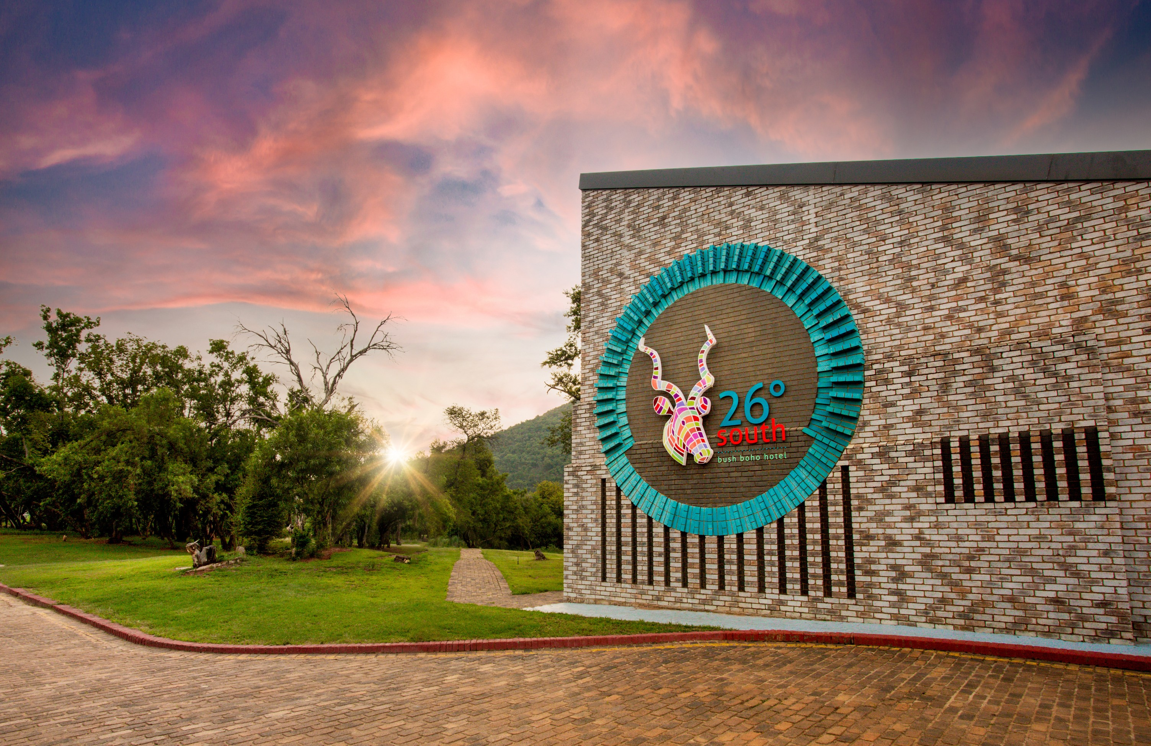72 Luxury Rooms
4 Suites
6 Conference venues Wedding venue
10 km from Lanseria International Airport and 45 km from OR Tambo

26° South Bush Boho Hotel offers all the creature comforts required for an unforgettable stay, within the soothing serenity of the African bush. The Magaliesberg mountain range forms a picturesque backdrop for weddings, corporate getaways and leisure seekers alike. Situated within the Cradle Moon Conservancy in Muldersdrift Gauteng, this private reserve provides the opportunity to escape the bustle of the city but is a convenient 25 minute drive from Lanseria International Airport and 1.5 hour drive from OR Tambo.

The hotel boasts 76 spacious rooms, stylishly appointed and over-looking our sparkling pool and the bushveld beyond. Each room offers free WiFi, selected DSTV channels, individual air- conditioning, a hairdryer, bath and shower combination with amenities, and tea/coffee making facilities. The conservancy is situated on the banks of a picturesque river and has a myriad of general species of game including, black and blue wildebeest, crocodile, rhino and hippo to name a few.

Whether it’s a romantic getaway for two, conferencing or team building, a weekend wedding, or just a quick getaway, 26° South is sure to meet the expectations of the most discerning of travellers.

FACT FILE

BUSH HOTEL IN MULDERSDRIFT GAUTENG 152 BEDS PRESENTED AS:
72 Luxury Rooms
4 Suites

EACH LUXURY ROOM FEATURES:
King size bed / Twin beds
Full en-suite bath & shower combination Dolce Vita pod coffee espresso machine Tea making facilities
Flat screen TV and limited DSTV channels Climate control air-conditioning
Free WiFi Access

THE SUITE IN COMBINATION AS ABOVE AND:
King size bed only
Lounge area with one sleeper couch which can accommodate two children under the age of 12 years

HOTEL FEATURES:
Swimming pool Lounge
Chow Baby Restaurant Bar
6 Conference venues Wedding venue
Uniquely designed L shaped pool table

ACTIVITIES:
Dawn & Dusk Game drives Mountain biking trails Hiking trails
Bird watching Quad Biking
Team Building Exercises

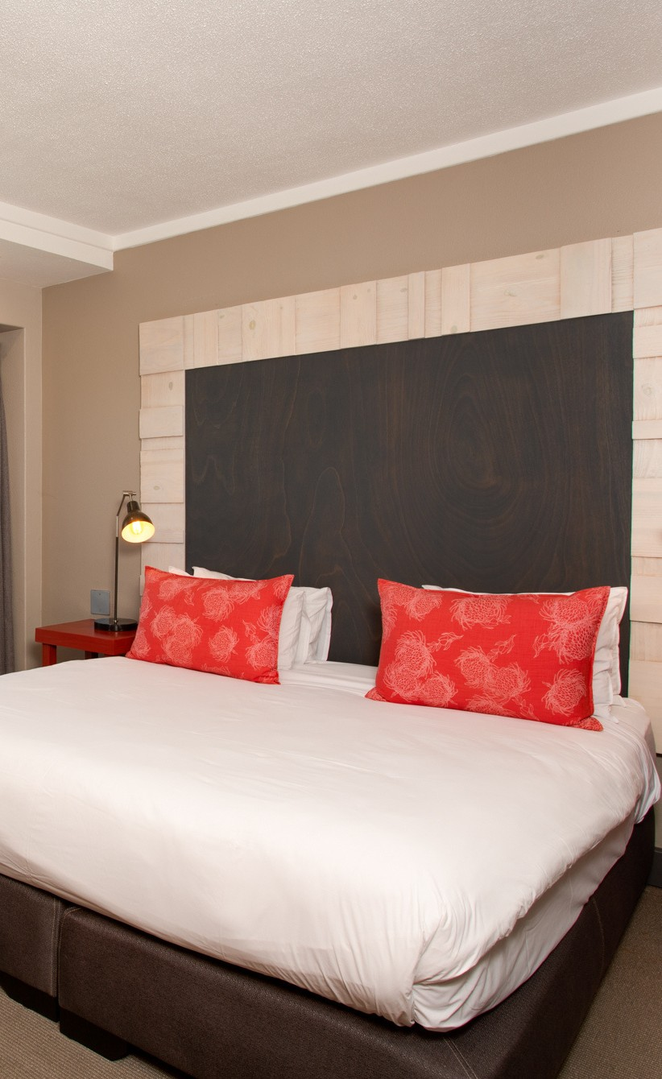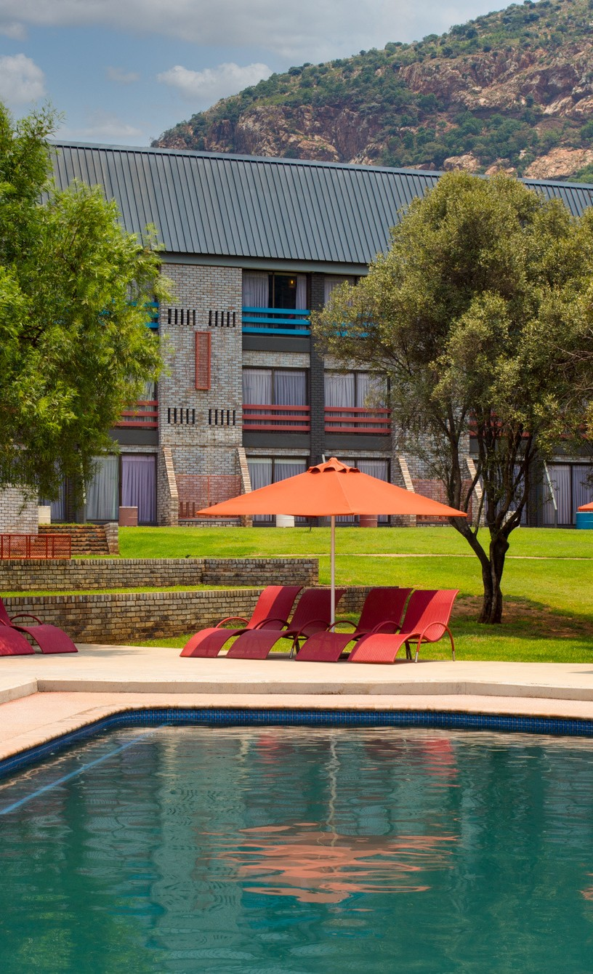Telephone: Website: Email:

Sales & Marketing:
+27 (10) 110 0802 | +27 (11) 568 4264
www.26dsouth.co.za info@26dsouth.co.za | reservations@26dsouth.co.za sales@anthology.co.za

